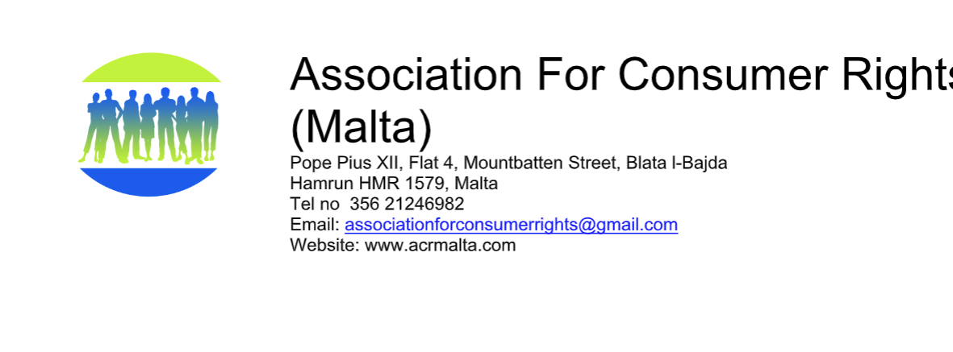
11th May 2021
COPING WITH LOANS AND DEBT
Invitation to:
Dear Colleagues and friends,
The President would like to invite you to a joint webinar organized by ACR and MACM (Malta Association of Credit Management) on the topic of coping with loans and debt.

The webinar will be held by ZOOM on Thursday 27 May 2021 between 5.30pm and 6.30pm.
For registration and invitation please send an email to the associationforconsumerrights@gmail.com (by return) showing your interest.

Debts in Malta are not a small problem. When we look at the court data, we find that in 2020, 1933 warrants were issued by the Qorti Magisterjali and 1832 by the Qorti Superjuri). From the Qorti Magisterjali there were issued 3186 judicial letters called 166A and from the Qorti Superjuri 168 judicial letters. These include both individual and corporate entities.

Agenda
5.30pm Introduction by ACR President Pauline Azzopardi
5.35pm Presentation by Josef Busuttil, Director General – MACM (Malta Association of Credit Management)
- Should people take bank loans or purchase goods on credit?
- How much should a person borrow?
- What factors should a person watch out for when taking up loans/credit?
- The banks or trade creditors request personal data prior to granting loans/credit. Why?
- Should the person requesting credit/loan be willing to share personal data with the bank/creditor? Why?
- Understanding the difference between Interest Rates and APRC.
- What data is available to lenders before they give you the loan or credit?
- How can I budget prior to borrowing from the bank or purchase goods on credit?
- What help can the lender help when you enter into arrears.
6.05pm Presentation by Pauline Azzopardi
- What are the remedies that a lender may offer if you go into arrears?
6.15pm Questions and comments
6.25pm Conclusion: ACR President
We look forward to meeting you to discuss this important theme.

Best regards,
Pauline Azzopardi
President ACR

ACR shall process Personal Data according to applicable legislation, particularly, Reg [EU] 2016/679 as well as the Data Protection Act, Chapter 586 of the Laws of Malta, amongst others. ACR shall be deemed to be a Data Controller of the personal data it processes in execution of its services. ACR processes this personal data since this is necessary for the performance of the webinar and for compliance with the law.

