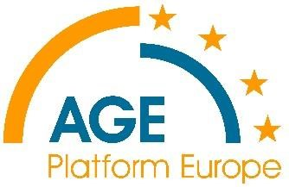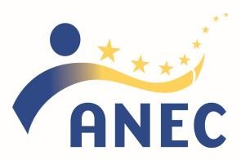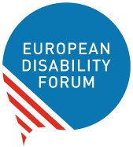

**ANEC-AGE-EDF Joint statement for UN International Day of Older Persons 1st October 2020**

**“Pandemics: how do they change the way we address age and ageing?”**

Despite the negative consequences of COVID-19, standards have proven key to protecting and supporting society in an emergency situation and can do so in the new normal ahead. From face masks to respirators, and accessibility of communication, we have all learnt the importance of standards in ensuring our safety and wellbeing.

The way we address age and ageing influences the way we provide support and care. The pandemic has shown the limits of our residential care systems, thus questioning our ways of thinking about later life. The pandemic has opened up the debate about the wider community context in which we grow old: this context must offer something new and empowering. This new approach would produce better standards and in the process challenge previous ways of thinking.

European Standards, if based on the principles of Design for all and used, can play an essential role in supporting everyone’s right to equal access, autonomy and participation. Design for All means designing products and services for as many consumers as possible, regardless of age and abilities. Only a European Standardisation System inclusive of the diversity of consumers can develop standards that meet the needs of a wider consumer base.

ANEC-AGE-EDF have been working jointly for many years, and are committed to continue to do so, in delivering products and services that address the needs of all consumers. Accessibility, usability, empowerment, privacy protection, choice, control, environmental and social impacts: they have to be front and centre in the management of the health and economic crisis.

*About AGE Platform Europe:* AGE Platform Europe is a European network of organisations of and for older people. We aim to voice and promote the interests of the 200 million older citizens aged 50+ in the European Union and to raise awareness of the issues that concern them most. [www.age-platform.eu](https://age-platform.us13.list-manage.com/track/click?u=cf3b9abedf63c20e4a7a3376c&id=7059ff0fac&e=6088eaea11)

*About ANEC:* ANEC is the European consumer voice in standardisation. We represent the European consumer interest in the creation of technical standards, especially those developed to support the implementation of European laws and public policies. [www.anec.eu](http://www.anec.eu/)

*About the European Disability Forum:* The European Disability Forum is an independent NGO that defends the interests of 80 million Europeans with disabilities. EDF is a unique platform which brings together representative organisations of persons with disabilities from across Europe. It is run by persons with disabilities and their families. EDF is a strong, united voice of persons with disabilities in Europe. [www.edf-feph.org](http://www.edf-feph.org/)

2